MUKAGEN
Autonomous Counter-UAS Detection, Fusion and Targeting Platform
Edge-native multi-sensor fusion. Autonomous targeting. Zero cloud dependency.
Caelus Industries | caelusindustries.com | info@caelusindustries.com
<50 ms  End-to-end latency | 1,000 m  Radar detection range | <100 ms  Time to confirmed track | <10 m  Position error at 500 m | 0  Cloud dependencies
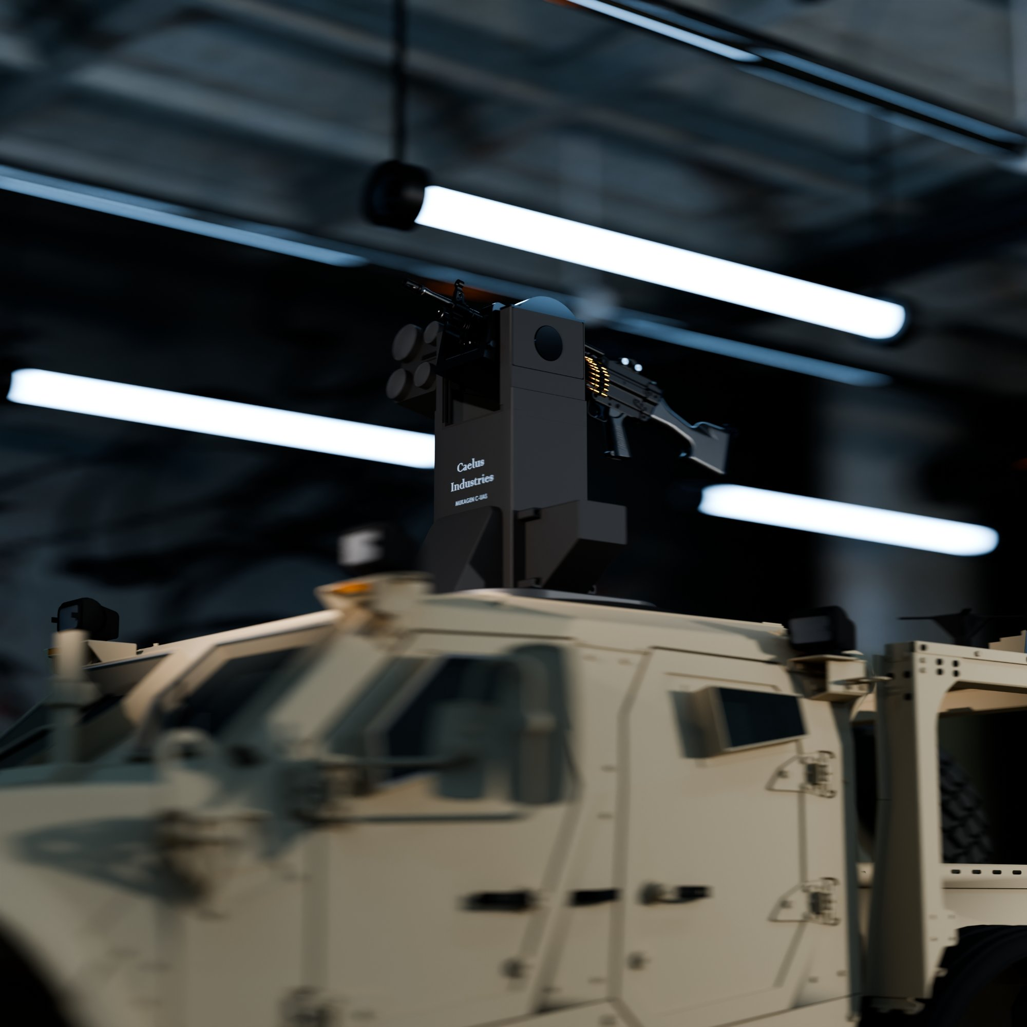
Autonomous counter-UAS detection, fusion and targeting. Zero operator input required post-lock.
Mukagen is an edge-native multi-sensor fusion platform that detects, classifies, tracks and cues an effector against hostile Class I–III UAVs in real time. The full perception and engagement pipeline runs on a single NVIDIA Jetson Orin NX with zero cloud dependency. Radar, EO camera and IMU data are fused via Unscented Kalman Filter into a single authoritative 3D track that drives a pan/tilt gimbal effector interface.

COMMERCIAL IN CONFIDENCE | For authorised recipients only | 2026
1. The Mukagen Platform

Mukagen is a single unified autonomous counter-UAS system consisting of two tightly integrated subsystems: a Vision Pipeline and a Sensor Abstraction Layer. Both ship as one deployable product on a man-portable compute and sensor assembly. The full stack runs on a single NVIDIA Jetson Orin NX with no network required in the engagement loop.
Every layer is designed to work together and can be monitored from the operator console. The system acquires, classifies and tracks targets without operator input, then cues the connected effector automatically.
VISION PIPELINE  Perception via YOLOv8n ONNX. ByteTrack multi-object tracking. UKF sensor fusion. Florence-2 VLM threat classification. BANE targeting engine output. | SENSOR ABSTRACTION  Hardware driver framework for radar, EO, IR and IMU. BaseSensor abstraction layer. Any new sensor type integrates in a single subclass. ZMQ track aggregation output. | OPERATOR CONSOLE  PyQt6 dark tactical interface. Live video with ByteTrack overlays. 3D scene rendering. Telemetry panel. Runs on Jetson or connected laptop.

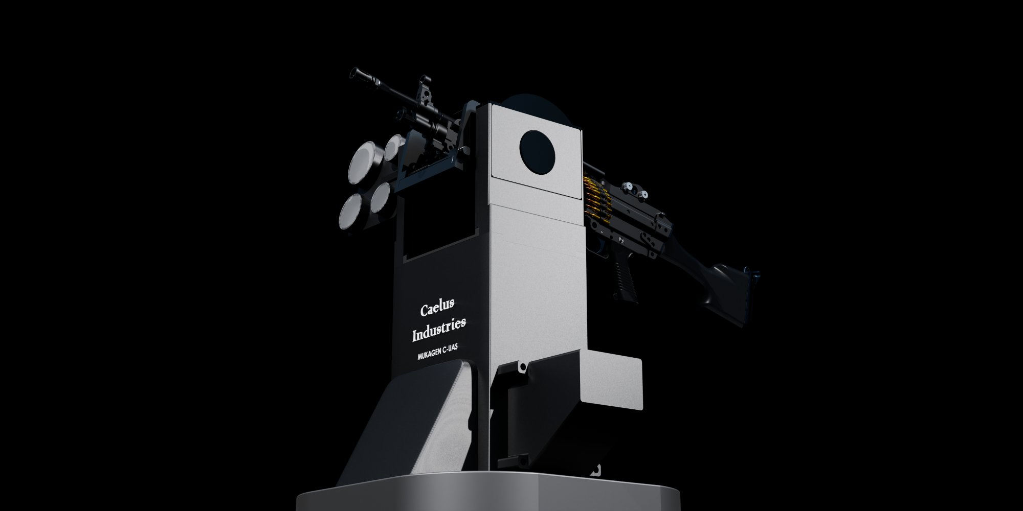 | 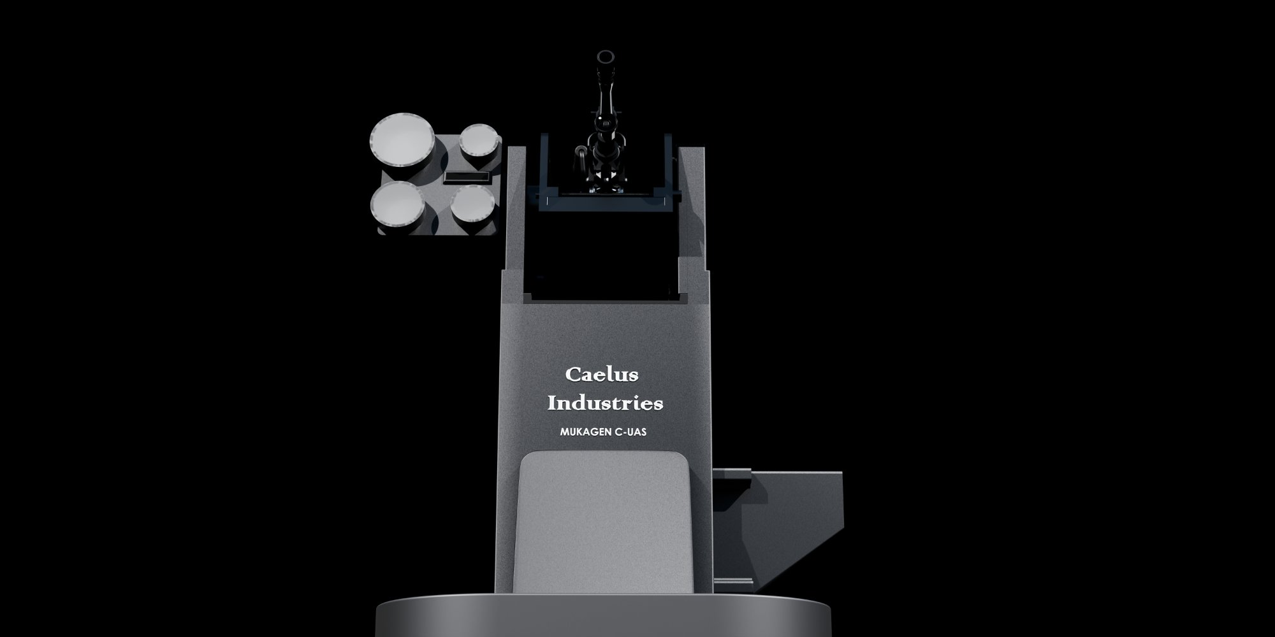
Mukagen sensor head and compute assembly | Caelus Industries

2. Detection and Acquisition

2.1 Platform and Sensors
Mukagen acquires targets autonomously using a 24 GHz FMCW radar for long-range detection and an EO camera with YOLOv8n for visual classification. An optional IR channel extends operation to low-light environments.

Specification | Value | Specification | Value
Compute platform | NVIDIA Jetson Orin NX | Form factor | Man-portable sensor head and compute unit
Primary radar | 24 GHz FMCW | Radar detection range | 1,000 m minimum
EO model | YOLOv8n ONNX, single class (drone) | EO detection range | 200 to 600 m
EO model accuracy | mAP50 greater than 90% | Optional sensor | IR camera for low-light operation
Target class | Class I–III UAS, below 25 kg | Max target velocity | Up to 140 km/h
Track confirmation | Tentative then Confirmed after 3 detections | Track dropout | Confirmed then Lost after 5 missed detections
Guidance update rate | Greater than 20 Hz | Time to confirmed track | Below 100 ms from camera frame

2.2 Sensor Suite
Sensor Suite
24 GHz FMCW Radar | Range, azimuth and radial velocity. Acquisition at 1,000 m minimum. Authoritative range source for UKF fusion. Covers Class I–III UAS up to 140 km/h.
EO Camera (Daylight) | YOLOv8n ONNX single-class drone detector. mAP50 greater than 90%. Supplies bearing and elevation angle measurements to the UKF.
IR Camera (Optional) | Extends detection to low-light and night conditions. Same bearing and elevation measurement interface as the EO channel.
IMU (9-axis) | Heading, pitch and roll at 200 Hz. Provides platform motion compensation for the UKF. IMU fallback for GPS-denied environments.
Gas Detection (Safety) | Catalytic bead / electrochemical hydrocarbon and H2S sensor. Hardware-enforced abort at 10 percent LEL or 10 ppm H2S. Battery-independent.

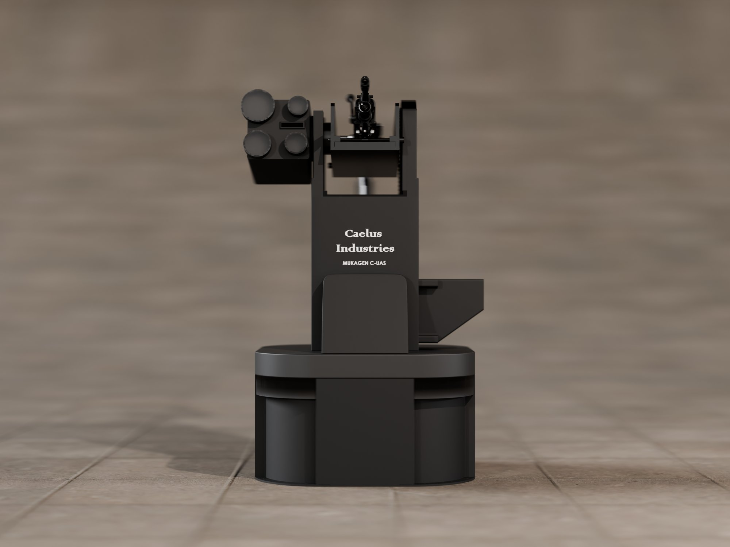 | 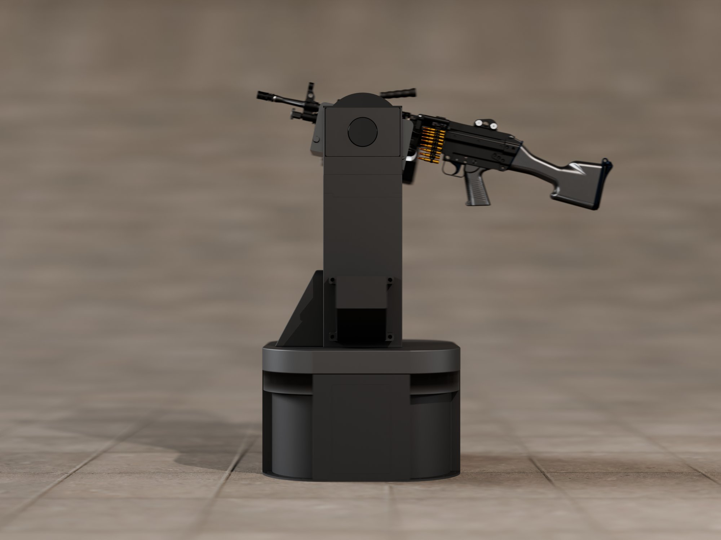
Mukagen deployment configurations | Caelus Industries

3. Sensor Fusion Architecture

3.1 Unscented Kalman Filter
Radar, EO camera and IMU are fused via an Unscented Kalman Filter (UKF) into a single authoritative 6-degree-of-freedom state vector. All effector cueing and targeting output derives from this track alone. The UKF degrades gracefully when any individual sensor is unavailable.

Specification | Value | Specification | Value
Filter type | Unscented Kalman Filter (UKF) | State vector | [x, y, z, vx, vy, vz] in metres
Radar contribution | Range, azimuth, radial velocity | EO contribution | Bearing and elevation (angle-only)
IMU contribution | Heading, pitch, roll for platform compensation | Range source primary | Radar — authoritative
Range source fallback | EO apparent size estimate | Position accuracy | Below 10 m error at 500 m range
End-to-end latency | Below 50 ms from camera frame to SensorDetection | Track persistence | ByteTrack — consistent IDs across all frames

4. Targeting and Engagement

4.1 Targeting Output
The BANE targeting engine converts the UKF state vector into gimbal corrections and 3D position output for the connected effector. No operator input is required once a track is confirmed.

Targeting Output
Pan correction | Degrees to rotate gimbal left or right to centre target
Tilt correction | Degrees to rotate gimbal up or down to centre target
Range estimate | Metres, derived from radar (authoritative) or EO apparent size (fallback)
3D position output | Cartesian [x, y, z] fused state for effector cueing
Threat classification | None / low / medium / high via Florence-2 VLM
Gimbal accuracy | Below 1 degree at 500 m range

4.2 Guidance and Engagement
Specification | Value | Specification | Value
Effector interface | Pan/tilt gimbal driven by BANE targeting engine | Kill mechanism | Directed-energy or kinetic — effector agnostic
Autonomous engagement | No operator input required post-lock | Time to track | Below 100 ms from camera frame to confirmed fused track
End-to-end latency | Below 50 ms camera frame to SensorDetection emitted | Update rate | Greater than 20 Hz guidance data output

5. Navigation and Resilience

Mukagen is designed for contested and denied environments. The full perception and fusion stack runs on-device with zero cloud dependency. GPS loss is handled by IMU fallback. OTA model updates propagate automatically when connectivity is available.

Navigation and Resilience
GPS-denied operation | IMU fallback maintains platform motion compensation in GPS-denied and contested environments
Offline operation | All inference and fusion runs on-device with zero cloud dependency required in the engagement loop
OTA model updates | New computer vision models push to all deployed units automatically via S3 when connectivity is available
Connectivity requirement | No network required in the engagement loop; OTA updates are opportunistic only
Simulation validation | Full NVIDIA Isaac Sim integration for pre-deployment pipeline validation against known drone trajectories

6. Operator Console

The Mukagen operator console is a PyQt6 desktop application with a dark tactical aesthetic. It runs directly on the Jetson Orin NX or on any connected laptop. Single-operator deployment with no external dependencies at launch.

Operator Console
Video Panel | Live camera feed with YOLOv8n bounding box overlays, crosshair reticle on locked target, and ByteTrack ID labels per object.
Telemetry Panel | Target status (tentative, confirmed, lost), range in metres, real-time pan and tilt corrections, inference time in milliseconds, and track confidence score.
3D Scene | Real-world target position rendered in 3D space relative to the Mukagen unit. Updated live from the UKF state vector with historical track path visualised.
Mission Controls | Mode selection (autonomous or supervised), track lock and unlock confirmation, engagement authorisation (if configured), external cue accept or reject, and ZMQ stream status.
Platform | PyQt6 desktop application. Dark tactical aesthetic. Runs on Jetson Orin NX or any connected laptop. Single-operator deployment.

7. Integration and Interfaces

Mukagen operates as a standalone system or integrates with external sensor networks and effectors. All track data is exported over ZMQ using the SensorDetection schema for downstream consumers.

Specification | Value | Specification | Value
External cue input | Radar, EO system or ATAK-format target coordinate | Standalone mode | Self-acquire with no external cue required
Track output | SensorDetection schema over ZMQ | 3D position output | Cartesian [x, y, z] fused state over ZMQ
CONDOR integration | Provides target designation over ZMQ pre-launch | Effector interface | Pan/tilt gimbal via BANE targeting engine

8. Key Differentiators

Mukagen vs. existing systems

Edge-native with zero cloud dependency.
The full perception, classification and fusion pipeline runs on a single Jetson Orin NX. No cloud uplink, no network latency, and no dependency on infrastructure that may not exist in a contested environment.
Multi-sensor UKF fusion.
Radar, EO and IMU are fused into a single authoritative 3D state vector via Unscented Kalman Filter. This is not a voting system — it is a mathematically rigorous track that degrades gracefully when any sensor is unavailable.
Persistent ByteTrack identity.
ByteTrack maintains consistent track IDs across every frame, ensuring the same target is tracked through occlusion, manoeuvre and sensor dropout. Validated for 100-plus frame persistence.
Intent classification via Florence-2 VLM.
Florence-2 VLM classifies the threat level of every detected UAV as none, low, medium or high. Mukagen understands what a drone is doing, not just that it is present, reducing false-positive engagement decisions.
Sensor-agnostic BaseSensor architecture.
The BaseSensor abstraction layer allows any new sensor modality to be integrated via a single subclass. LRF, thermal, acoustic or future sensor types slot in without re-architecting the fusion or tracking stack.
Simulation-validated pipeline.
Full NVIDIA Isaac Sim integration enables pre-deployment validation of the entire pipeline against known drone trajectories with ground-truth position data. Every deployment ships with a validated performance baseline.

9. MVP Success Criteria

The following criteria define the MVP acceptance gate for the Mukagen platform.
- Autonomous target detection and track confirmation without operator input
- Successful EO and radar fusion producing a valid 3D position estimate
- ByteTrack persistent track ID maintained across 100 or more consecutive frames
- End-to-end latency below 50 ms on Jetson Orin NX
- Pan/tilt gimbal corrections accurate to below 1 degree at 500 m
- Operates without GPS or network connectivity
- Full pipeline validated in Isaac Sim against known drone trajectory
- Single-operator deployment with no external dependencies at launch

10. Get Started

Requirements Review  We review your operating environment, threat profile, sensor constraints and regulatory context and confirm deployment feasibility and scope. | Demonstration  Live platform demonstration and, where feasible, a field demonstration against a representative target class. See the full tracking and engagement workflow end-to-end. | Pilot Deployment  First live deployment on your target environment. Full tracking performance report delivered within 24 hours of mission completion.

caelusindustries.com | info@caelusindustries.com
COMMERCIAL IN CONFIDENCE · Caelus Industries · 2026 · Not for external distribution without authorisation

